***[Capstone Category]***

|  |  |
| --- | --- |
| **Project Name** | **Autonomous Multiple Cycle Farming in Space** |
| Team Lead: | Courtney Cline |
| Team Member(s): | Dominic Allard, Philip Bernhard, Joshua Calhoun, Courtney Cline, Giampiero Corsbie, Timothy Frazier, Kali Jenson, Bryce Johnson, & Christopher Millsap |
| Faculty Advisor(s): | Dr. Elisabeth Kames, Mechanical Engineering & Dr. Philip Chan, Computer Science, Florida Institute of Technology |

**\*\*do not change font size or text color above this message/delete this before completion or put in a category. The category will be put in by Staff after submission \*\***

Project Description: With NASA gearing up for the Artemis program and space exploration expanding rapidly to accommodate life beyond Earth, there exists a need to grow food autonomously that can support humans reliably, without compromising valuable time, or energy, from other missions in space. Therefore, students across multiple disciplines joined forces to build an Autonomous Multiple Cycle Farming System (AMCF) that grows plants autonomously through robotic functions with limited human interaction for multiple cycles.

System Design: To make an autonomous system that seeds, grows, and harvests plants, three major systems are needed: water delivery, planting system, and base. In conjunction with these three systems, there will need to be a power supply, lighting, nutrients, and plumbing for support. Design is in accordance with SSP 52000-IDD-ERP NASA requirements on International Space Station.

Limited Competition: These engineering students have been interfacing with NASA Kennedy Space Center regularly, as they are experts of similar, but less autonomous programs, such as The Vegetable Production System (VEGGIE). The VEGGIE is a current solution for growing food in microgravity, already tested on the International Space Station. However, there are major differences between VEGGIE and AMCF. First, VEGGIE uses pillows to contain the seed and substrate in microgravity. In contrast, the AMCF will use a tray coupled with a nutrient solution dissolvable in water, eliminating the need for soil and allowing for more scalability. Second, VEGGIE requires astronaut delivery of water and seeds. Whereas, the AMCF will autonomously deliver water and plant seeds, eliminating much of the time spent by astronauts.

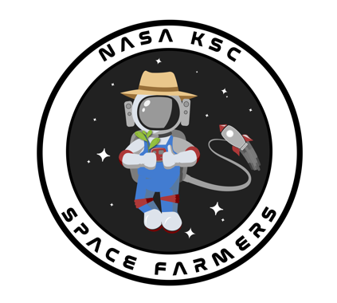

Future Plans: It is with great pleasure to announce that we have already submitted the Autonomous Multiple Cycle Farming System concept to two different NASA programs: “Technology Advancement Utilizing Suborbital Flight Opportunities ‘Tech Flights’,“ as well as “Student Payload Opportunity with Citizen Science (SPOCS)” at Johnson Space Center.